Advanced Health Economic Modelling
Instructions for computer lab survival analysis

In this computer practical you will use:
- The four Excel files, R project and an R script provided on CANVAS (Make sure to save everything in one folder for the remainder of the practical. We recommend downloading the entire folder from Canvas and store this on a location place on your computer (not your download folder!)
- Two scientific papers (link provided on Canvas):
  - de Bono et al., 2010 - Prednisone plus cabazitaxel or mitoxantrone for metastatic castration-resistant prostate cancer progressing after docetaxel treatment: a randomised open-label trial. The Lancet, Volume 376, Issue 9747, 1147 - 1154
  - Bahl et al., 2013 - Impact of cabazitaxel on 2-year survival and palliation of tumour-related pain in men with metastatic castration-resistant prostate cancer treated in the TROPIC trial, Annals of Oncology, Volume 24, Issue 9, 2402-2408.
- R and R studio (please make sure you have this software downloaded)
  - University computers: this can be done through the software centre
  - Personal computer: use the instructions on these websites – it is freely available.
    - R: https://rstudio-education.github.io/hopr/starting.html (Explains what R and R studio do)
    - R studio: https://posit.co/download/rstudio-desktop/#download (download free desktop version)

Start by opening Excel on your computer. Once you have opened Excel, please follow the set-up step below. This fixes one of the most common issues experienced by students in this exercise.

Excel English vs European number set up.
Windows:
- In Excel go to File -> Options -> Advanced
- Untick “Use system separators” and then please ensure that the decimals is ‘ .’ (i.e. a full stop) and thousands is ‘ ,’ (i.e. a comma) as per the English numerical system. It should look like this:
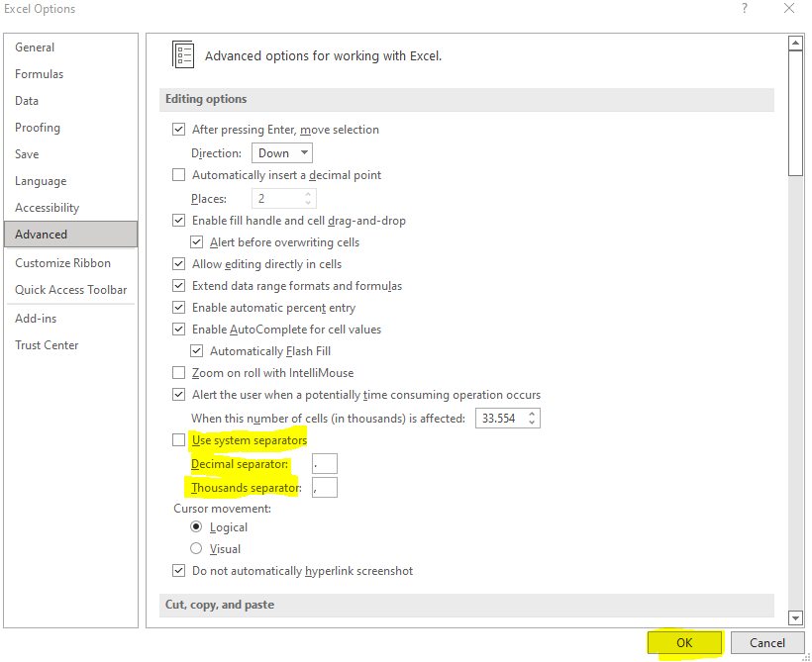
- And press OK. Make sure this gets applied to all Excel files that are required for this practical.
Mac:
- In Excel go to Microsoft Excel (next to apple logo) -> Preferences -> Edit
- Untick “Use system separators” and then please ensure that the decimals is ‘ .’ (i.e. a full stop) and thousands is ‘ ,’ (i.e. a comma) as per the English numerical system. It should look like this:
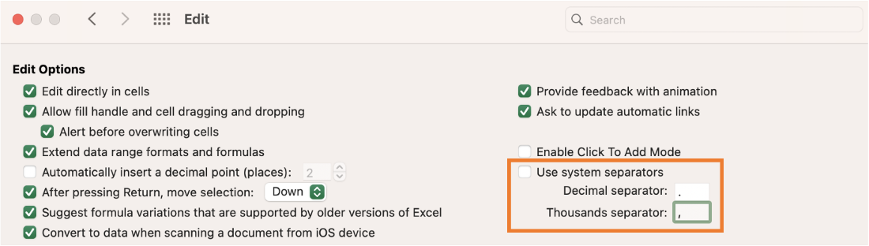

Now you are ready to start with the questions!

Q0:
Open both the de Bono et al. (2010) and the Bahl et al. (2013) papers. Compare Figure 2 from de Bono et al. (2010) with Figure 1 from Bahl et al. (2013). What are the main differences, and which paper should we use for better overall survival (OS) estimates?

In order to estimate transitions of the patients, you would normally need the raw patient-level data on overall survival (OS) and progression free survival (PFS) from the trial, and, if not all patients have progressed or died, then fit parametric survival curves (e.g., exponential, Weibull, log-normal, log-logistic etc.) through them. The type of output you will get from such a patient-level survival analysis is demonstrated in Table 3.2 from the Briggs et al. book.
Since we do not have the patient-level data, but only the published KM curves, we need to create pseudo-patient-level data (i.e., create data that will lead to the same KM curve as published) to be able to use parametric survival modelling. For this purpose, we will use the published OS (Overall Survival) curves in the updated Bahl et al 2013 paper and PFS (Progression Free Survival) curves in the original Bono et al 2010 paper and follow the method described in the Hoyle & Henley paper.
The relevant X and Y points from the corresponding Kaplan Meier curves are already extracted for you in the relevant Excel files using the WebPlotDigitizer4.1 software.

Q1:
Open the XY sheet in the Hoyle_and_Henley_Bahl_OS_Mito.xls file. Check if these values are in line with the graph of the OS Kaplan-Meier curve of mitoxantrone from the Bahl 2013 paper. (Hint: comparing values is easier if you add the image of the figure to the Excel) Next, open the “Number events & censored” sheet and fill in the white cells in column B with these “X” values (i.e. 0, 1.5, 3, …) and fill the white cells in column E with the “Y” values (i.e. 1, 0.97, 0.96, … ). Finally, fill in the white cells in column H with the corresponding “number at risk” values given under the OS KM curve in Bahl 2013 paper (i.e. 377, 299, 195, …).

Can you recognize the calculations in columns I, J, K, L, M and N from the Hoyle and Henley 2011 article?

Are there patients at risk at the last time point? What is this last-time point? And how many patients were still at risk at this last time point? Hint: check last row of column B and H and check if this is in line with the box (columns 14O:16T) and number at risk of the figure from the paper.

Q2:
Check the numbers under empirical survival probability S(t) (column E). At the point where the value is 0.500, we observe the median survival time (in column B). However, column E never becomes exactly 0.50. So, find the time at which the survival is slightly above 0.5 and the next time where survival is just below 0.5. Take the average of these times and check if this value corresponds to the median of the OS KM curve given in the Bahl et al. 2013 paper in Figure 1 and to the reported median in the de Bono 2010 paper.

Q3:
Now open the “R data” sheet. What do these number correspond to? Can you say how many patients died and were censored between time points 0 and 1.5? How about between time points 15 and 16.5?

Q4:
Follow the steps below:
- Make sure you watch the instruction video (see Canvas).
- Download all the files needed for this computer practical and save them in the same folder
- Open the R project. (Double click on the files ending with .Rproj)
- R studio will be opened - check that you see the folder name on the top right
- Open the R script. (file ending with .R – “R script Hoyle Henley combined.R”, right bottom of R studio)
- Read the green text in the script.
- Run the code from Part I step by step.
Or press Ctrl/command and Enter keys simultaneously
- Note: R will read the data from the Excel files. Therefore, it is important that the file name exactly match with the file names in the script. So please don’t rename the Excel files.

Fill in the table below with the corresponding results from R.
OS for mitoxandrone
 | exponential | weibull | lognormal | loglogistic
AIC
intercept
log(scale)

Next, repeat the steps you did in Q1 for the OS of Caba and the PFS of both Mito and Caba. You will use the following Excel files correspondingly:
- OS of Cabazitaxel (Hoyle_and_Henley_Bahl_OS_Caba.xlsm)
- PFS of Mitoxantrone (Hoyle_and_Henley_ PFS_Mito.xlsm)
- PFS of Cabazitaxel (Hoyle_and_Henley_ PFS_Caba.xlsm).

Q5: After you filled-in the “Number events & censored”-sheet in all the Excel files, you can now use the R code from Part II. This code will repeat the exercise of Q4 for all the dataset at once.
In addition, the R code exports the results in an excel sheet (output_parametric_survival_model_parameters.xlsm). This file will show-up in your folder. Use this file to fill out the tables below.

a.

OS for cabazitaxel
 | exponential | weibull | lognormal | loglogistic
AIC
intercept
log(scale)

b.

PFS for mitoxandrone
 | exponential | weibull | lognormal | loglogistic
AIC
intercept
log(scale)

c.

PFS for cabazitaxel
 | exponential | weibull | lognormal | loglogistic
AIC
intercept
log(scale)

Q6:
The parametric formulations for exponential, Weibull, lognormal and loglogistic distributions are as follows.
 | Exponential | Weibull | lognormal | loglogistic
Formula | 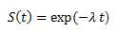  Lambda (λ) =  exp(-intercept) | 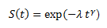  Lambda =  exp(-intercept/scale)  Gamma (γ) = 1/scale | 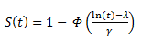  Lambda = intercept  Gamma = scale | 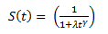  Lambda =  exp(-intercept/scale)  Gamma= 1/scale

For the OS of mitoxantrone, based on the formulae above and the parameters obtained from R, please calculate the S(t) (with pen/paper or in Excel) for t=16 weeks for each of the 4 distributions (recall that scale= exp(logscale) = e^{logscale} and the intercept and logscale values are based on a monthly time scale, ɸ(x) is the standard cumulative normal distribution function, and its values can be found through z-tables).

It is now time to add the survival parameter information to the Cabazitaxel model template. This is the template you will use the rest of the course to make the cost-effectiveness model. The sheet might feel overwhelming, but for now you can focus on one sheet only. The “extrapolation” sheet.
Q7:
Open the “extrapolation” sheet of the “Cabazitaxel model template.xlsm” file, and paste the corresponding AIC, intercept and logscale parameters for each distribution to the corresponding cells (AD31:AS33). (Tip: copy the values from the output_parametric_survival_model_parameters.xlsm and make use of “save special” and select “values”. This keeps the layout consistent. IMPORTANT: make sure you past the right value at the right position, the order of OS and PFS and drugs might be different between the sheets). Make sure you save this file. You need this in the follow-up assignment.
Next fill in the related Cholesky decomposition of the covariance matrices in cells AC5:AO22. You will not use the Cholesky matrix outputs this week, but they will be necessary for the probabilistic sensitivity analysis part later in this course.
Check the cell formulae in the same sheet in columns D to S, under row 15. What are these formulae? Compare the results you found in the previous question for OS results in week 16, with the corresponding Excel results you have in front of you.

Q8:
For each of the 4 curves (PFS caba and mito, OS caba and mito), which parametric model appears to have the best statistical fit, based on AIC? And the worst?

 | Best | Worst
OS mito
OS caba
PFS mito
PFS caba

Briggs A, Schulper M, Claxton K. Chapter 4. Making decision models probabilistic. In: Decision Modelling for Health Economic Evaluation. Oxford, UK: Oxford University Press; 2007: 77-120.
Bahl, A., et al. "Impact of cabazitaxel on 2-year survival and palliation of tumour-related pain in men with metastatic castration-resistant prostate cancer treated in the TROPIC trial." Annals of Oncology 24.9 (2013): 2402-2408.
de Bono JS, Oudard S, Ozguroglu M, et al. Prednisone plus cabazitaxel or mitoxantrone for metastatic castration-resistant prostate cancer progressing after docetaxel treatment: a randomised open-label trial. Lancet 2010;376:1147-54.
Hoyle and Henley BMC Medical Research Methodology 2011, 11:139

